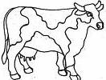
In the name of Allah, Most Gracious, Most Merciful
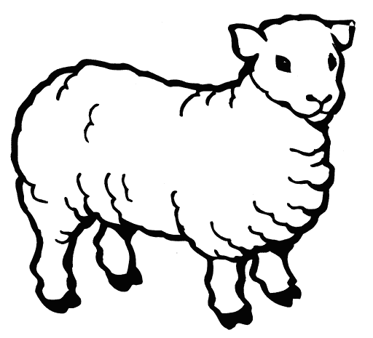
Qurban/Aqiqah 1438H/2017
$1400
cow
$200
Sheep
sheep/
sheep
In aid of poor Muslims in China

Particulars of Contact Person
Name:
Address:& Postal Code:
Mobile/home Tel: | Email:
Write yes(+) or no (X) in the bracket Do U want qurban certificate ( )
*Qurban photos will be emailed to all donors.
Full Name (BLOCK LETTERS) | Please tick accordingly |  | Qty | Total
 | Aqiqah | Qurban
1.
2.
3.
4.
5.
6.
7.
Sadaqah / Zakat Cheq No. / Cash: |  | TOTAL

If you wish to sadaqah or zakat for our community AMAL projects please indicate below:
Sadaqah for the Poor/Disabled S$
Teacher’s Wages S$
Water Projects S$
Fidyah S$
Ramadan Iftar S$

S$
Madrasah S$
Muslim Preschool S$
Mosque Building Fund S$
Orphanage Home S$
Poor Students Education S$

Methods of Payment:
- Please cross CHEQUE made payable to ‘Mariah Mah’ and mail your payment together with this form to Marine parade Road. Blk 5000K #13-47 Lagoon View, Singapore 449292.

- Or BANK TRANSFER: DBS AutoSaveCurrent acct: 0300040368 .Please mail this form together with the Bank transfer slip or Post Office Money order to above address.

- CASH payment; at 263 Joo Chiat Road, Singapore 427521.
For further details and enquiries, please contact: Sister Mariah Mah (Darul Arqam Member)

Tel: 6241-2000 (Mobile) 96163468,96567315

Email mm@chinamuslim.net Website: www.chinamuslim.net

Qurban & Tour in Yunnan Province!! Book Fast! Contact Mariah for itinerary
QURBAN TOUR Yunnan –Guizhou --8 days—( 31August ---7Septemeber 2017 Witness QURBAN ! Write in for itinerary if interested! mm@chinamuslim.net

